
WAVZ
FOR DIGITAL TRANSFORMATION

Enabling organizations to grow,
innovate, and evolve with confidence.

2008  Year Established | 2  Regional Offices | 15+  Years of Delivery | MEA  Market Coverage

Company Profile · 2026
Cairo, Egypt · Riyadh, Saudi Arabia · wavz.com.eg

01 | About the Company  ⌂ Who We Are

Established in 2008 and headquartered in Cairo, Egypt, WAVZ for Digital Transformation has spent over 15 years helping government organizations and enterprises realize their full potential. Through outcome-driven technology solutions, we enable clients to transform their operations, modernize IT infrastructure, and build the resilience needed to grow.
In 2024, we expanded into Saudi Arabia with a subsidiary in Riyadh — a deliberate step in our broader strategy to serve the Middle East and Africa market with greater depth and proximity.
WAVZ is technology-agnostic — we partner with SAP, Oracle, Microsoft, Teradata, Informatica, Cisco, and many others, selecting the right tools based on each client’s specific needs, not vendor allegiance.

VISION
To become the region’s trusted visionary partner, enabling organizations to grow, innovate, and evolve with confidence.

MISSION
We empower organizations with an innovative portfolio of advisory and operational services, combining delivery excellence and partnerships to ensure resilient and sustainable growth.

02 | Value Proposition  What Sets Us Apart

Our value is not found in any single technology. It lies in the combination of deep domain expertise, technology independence, and a disciplined delivery framework that guides every engagement from first assessment through to long-term operation.
⊕︎ | Technology Agnosticism  We design solutions based exclusively on client outcomes. Our broad partner ecosystem means we can always select — and integrate — the right tools for the right context, without bias toward any single vendor. |  | ↻ | End-to-End Accountability  We engage across the full transformation lifecycle: strategy, roadmap, implementation, and managed operations. Clients benefit from a single accountable partner rather than fragmented vendor relationships.
✓︎ | Delivery Excellence  Disciplined governance, rigorous quality assurance, and SLA-driven accountability are embedded in every engagement. Commitments are met. Risks are managed proactively. Outcomes are measurable. |  | ◉ | Regional Depth, Global Capability  On-the-ground presence in Cairo and Riyadh, supported by a wide partner network, enables us to combine global best practices with deep regional knowledge of market dynamics and regulatory environments.

03 | Our Approach  From Vision to Results

Every WAVZ engagement follows a structured, four-phase lifecycle — purpose-built to maximize value and minimize disruption. Continuous improvement is embedded throughout, not bolted on at the end.
01  Assess  Evaluate current state, identify risks, uncover digital opportunities | ▶ | 02  Roadmap  Prioritize initiatives and define a strategic path to desired outcomes | ▶ | 03  Implement  Deliver with strict governance, QA standards, and seamless integration | ▶ | 04  Run & Operate  Managed services with guaranteed SLAs and continuous optimization

↻ Continuous Improvement · Embedded across every phase — feedback loops, governance reviews, and optimization cycles continuously refine outcomes after go-live.

04 | Services & Solutions  Our Portfolio

WAVZ delivers a comprehensive, integrated solutions portfolio spanning four core practice areas — together covering the full spectrum of enterprise digital transformation, from infrastructure resilience to AI-powered intelligence.
Practice 01  Managed Services  24/7 operational coverage across NOC, SOC, AMS, Cloud Operations, Data Centre, and Command & Control. One operating model. Multiple service towers. Unified SLA governance. |  | Practice 02  SAP Solutions & Services  Certified SAP partner delivering S/4HANA implementation across on-premise, public cloud, and private cloud — plus rescue, optimization, ongoing support, and 24/7 monitoring.
Practice 03  Oracle Technology Solutions  Full-stack Oracle delivery across OCI, Exadata, Fusion Cloud, EBS, and APEX. Hybrid-ready across on-premise and cloud with FinOps-managed operations and vector/AI-enabled database capabilities. |  | Practice 04  Data & AI Solutions  From data foundation and governance through modern analytics to Generative AI, agentic automation, and intelligent workflows — partnering with Teradata, Microsoft, Informatica, Temenos, Qlik, UiPath, and more.

MANAGED SERVICES
At a Glance
Network Operations  (NOC) | Service Operations  (SOC) | Command & Control  (CCC) | App Managed Services  (AMS)
Cloud Managed Services  (CMS) | Data Centre Operations  (DC) | Field Operations  (FO) | PMO & Decision Support  (PMO)

05 | Strategic Partnerships  Global Partners, Local Impact

Our Technology Partners Include: SAP · Oracle · Microsoft · Teradata · Temenos · Informatica · Cisco · Qlik · UiPath · Erwin by Quest · Huawei · Palo Alto · Dell and many others

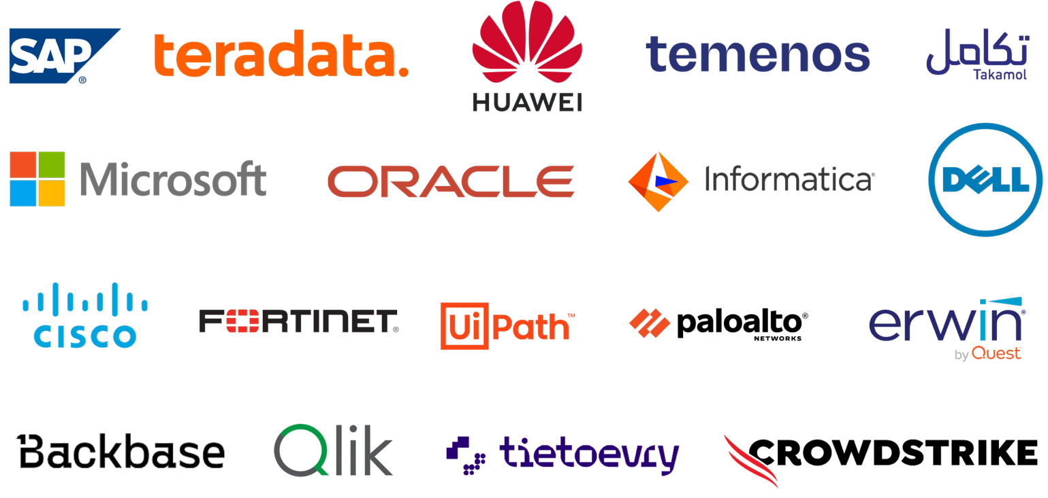
WAVZ’s partnership ecosystem is a core pillar of its value proposition. We maintain deep technical and commercial alliances with the world’s foremost technology providers — ensuring our clients have access to enterprise-grade capabilities, certified expertise, and global support structures.
These relationships do more than expand our technical breadth — they give clients preferential access to roadmaps, innovation previews, and escalation paths. Most importantly, our technology-agnostic philosophy ensures that partnerships inform our capabilities without constraining our recommendations.

06 | Industries Served  Sectors We Know Best

WAVZ has built its track record across the most demanding, regulated, and mission-critical sectors of the regional economy — environments where reliability, compliance, and performance are non-negotiable.
⌂ | Government & Public Sector  Supporting national digital transformation programs — from service modernization to data-driven governance and IT infrastructure overhaul. |  | $ | Banking & Financial Services  Delivering enterprise data platforms, managed security operations, and mission-critical systems for banks where uptime and data integrity are paramount.
≋ | Telecommunications  Enabling operators to optimize IT landscapes, integrate complex systems, and leverage data and AI to enhance customer experience and operational efficiency. |  | ▣ | Large Enterprise  Serving diversified private-sector organizations with enterprise applications, cloud services, and managed operations that scale with business growth.

07 | Key Capabilities  How We Deliver

WAVZ’s operational and strategic strengths are the product of over 15 years of continuous refinement across complex, high-stakes environments.
01 | Structured Delivery Methodology  A proven four-phase framework — Assess, Roadmap, Implement, Run & Operate — with continuous improvement embedded throughout, providing a governed path from diagnosis to sustainable performance.
02 | 24/7 Operational Infrastructure  Dedicated NOC, SOC, and CCC capabilities ensure round-the-clock visibility, rapid incident response, and proactive risk management across client environments.
03 | Certified Technical Expertise  Multidisciplinary teams with validated certifications across SAP, Oracle, Microsoft, and other major platforms — ensuring every engagement is staffed with specialists, not generalists.
04 | PMO & Program Governance  A dedicated PMO function provides KPI reporting, executive decision support, and disciplined program oversight — keeping large-scale transformations on track and accountable.
05 | Scalable Regional Presence  Operations in Cairo and Riyadh, supported by a broader MEA partner network, deliver the geographic coverage and local knowledge to serve clients across the region effectively.

08 | Why Choose Us  The WAVZ Difference

✦︎ Seasoned Expertise
Deep, hands-on experience in banking, communications, and government — the environments where precision is most consequential.

✦︎ Technology Independence
We recommend what’s right for your business, not what benefits our commercial interests. Solutions designed on merit.

✦︎ World-Class Partnerships
Strategic alliances with SAP, Oracle, Microsoft, Temenos, Teradata, and others bring certified, enterprise-grade capabilities to every engagement.

✦︎ Proven Track Record
Over 15 years of reliable, high-quality delivery across the region’s most complex transformation programs — since 2008.

✦︎ Committed Regional Partner
Growing presence in Egypt and Saudi Arabia, with deep local knowledge, cultural alignment, and an internationally structured governance model.

09 | Get in Touch  Ready to Start?

Digital transformation demands a partner with the expertise to navigate complexity, the integrity to provide honest counsel, and the resilience to deliver under pressure. WAVZ has built its reputation on precisely these qualities.
As enterprises and governments across the region enter an era of AI-driven intelligence and cloud-native operations, we are positioned to be the trusted partner that helps organizations not just implement solutions — but evolve with confidence.
▣  Visit Us  Maadi Technology Park,  Block MB3, Building B2,  Cairo, Egypt | ☎︎  Call Us  +2 02 2120 1430  Sun – Thu, 9am – 5pm | ✉︎  Email & Web  info@wavz.com.eg  wavz.com.eg

WAVZ for Digital Transformation
wavz.com.eg

